**Lesson 2 Demo 1**

**Execute Basic Linux Commands**



Steps to be followed:

1. Executing basic Linux commands.

**Step 1: Executing basic Linux commands**

1. List the files or folders present in the current directory.

***ls***

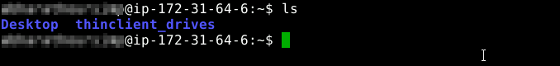

1. Create a new directory in the current folder, and check if the folder is created.  
   ***mkdir New_Folder***

***ls***

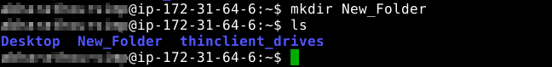

1. Navigate to the **New_Folder** directory by changing the current directory.

***cd New_Folder***



1. Write some text in a demo file, and display the content of the file

***echo "This is a demo file" > demo.txt***

***cat demo.txt***

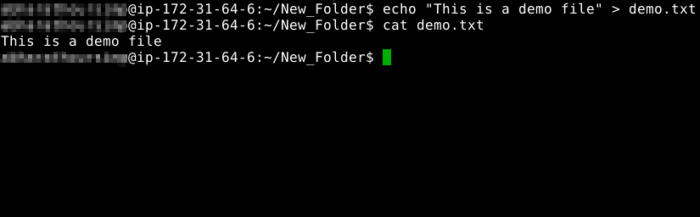

1. Change the mode of the *demo.txt* file to read only

***chmod -r demo.txt***



1. Remove the *demo.txt* file from the folder, and list the files in the folder

***rm demo.txt***



1. Change the current user as a super/root user

***sudo su***



1. Install git using the *apt-get* package manager

***apt-get install git***

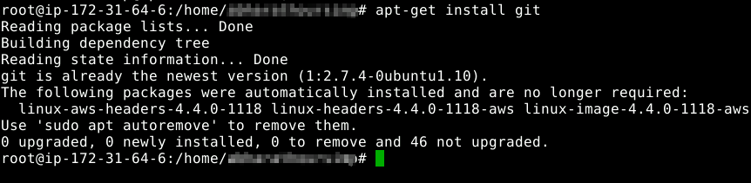

1. List all the previously used commands

***history***

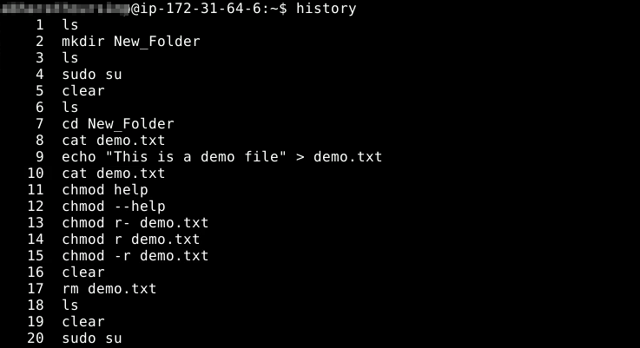

1. Clear the Terminal screen.

***clear***



1.11 Creating a file using vi.

***vi <filename>.<extension>***



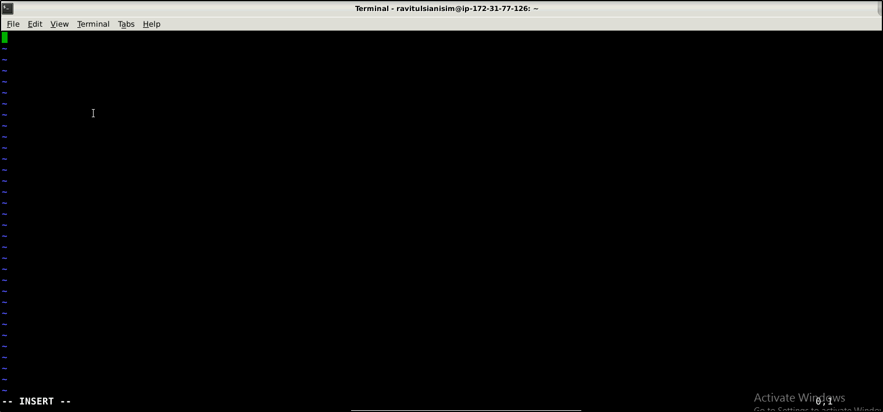

1.12 Changing file permissions.

***chmod <permission code> <filename>.<extension>***

*For ex: chmod 777 test.txt*

**

1.13 Unzipping a file.

***tar -xf <filename>.tar.gz***

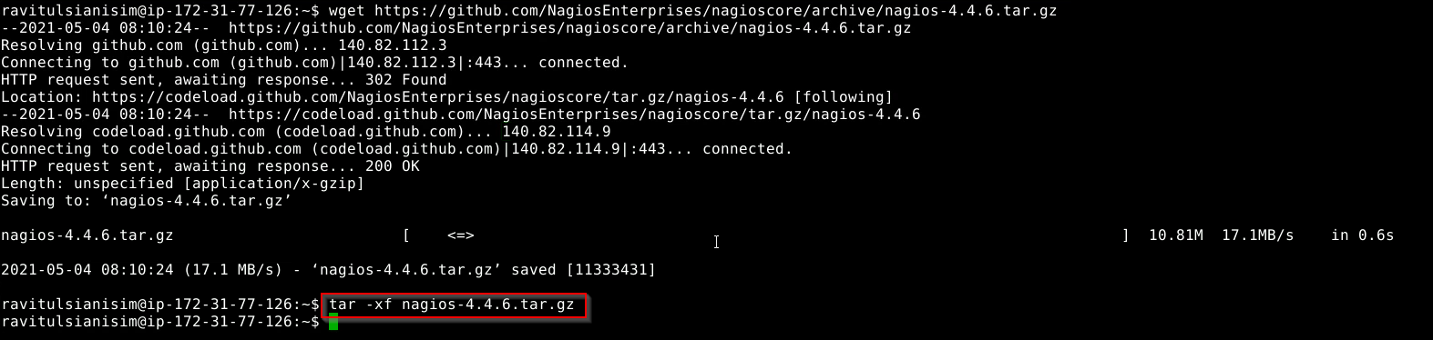

***unzip <filename>.zip***

